**ANALYSING HOUSING PRICES IN METROPOLITAN CITIES**

**Project work submitted by**

**Roll No: C21UG105STA015 Name: Nithishkumar. K**

**C21UG105STA004 Deivanayagam. T**

**C21UG105STA006 Hariharan. M**

**C21UG105STA010 Karthick. V**

**Under the Guidance of**

**Dr. M. GOVINDHAN, M.Sc., Ph.D.**

**Guest Lecturer**

**DEPARTMENT OF STATISTICS**

**GOVERNMENT ARTS COLLEGE**

**Dharmapuri – 636 705**

**(Affiliated to Periyar University, Salem)**

**October -2023**

**1. Introduction**

**1.1 OVERVIEW**

Analysing housing prices in metropolitan cities involves various steps:

* Data Collection: Gather data on property listings, including details like location, size, amenities, and prices. Online real estate websites, government records, or APIs can be sources.
* Data Cleaning: Clean the data by handling missing values, outliers, and inconsistencies.

**1.2 PURPOSE**

Analysing housing prices in metropolitan cities serves several purposes:

* Investment Decisions: Investors use price analysis to make informed decisions on buying, selling, or holding real estate assets.
* Real Estate Valuation: It helps property appraisers and assessors determine the fair market value of properties for taxation or lending purposes.

**1.3 ADVANTAGES & DISADVANTAGES**

**Advantages**

Analysing housing prices in metropolitan cities offers several advantages:

* Informed Decision-Making: Buyers, sellers, and investors can make more informed decisions regarding purchasing, selling, or investing in real estate properties.
* Property Valuation: It provides a basis for determining the fair market value of properties, which is crucial for taxation, lending, and insurance purposes.
* Market Insights: Real estate professionals can gain insights into market trends, helping them predict future developments and opportunities.

**Disadvantages:**

Analysing housing prices in metropolitan cities can have several disadvantages:

* Complexity and Volatility: Metropolitan housing markets are often complex and highly volatile, making it challenging to predict trends accurately.
* Data Availability: Access to reliable and up-to-date housing data can be limited, making analysis less precise.
* Rapid Changes: Factors like economic shifts, government policies, and urban development can rapidly impact housing prices, making long-term predictions uncertain.

**1.4 APPLICATION**

Analysing housing prices in metropolitan cities has several valuable applications:

* Real Estate Investment: Investors use housing price analysis to identify potentially lucrative real estate investment opportunities.
* Home buying: Prospective homebuyers can make informed decisions based on current and future housing market trends.
* Rental Market: Landlords and property managers can set competitive rental rates and make investment decisions in the rental market.

**2. PROBLEMS DEFINITION & DESIGN THINKING**

**Fig 1: Empathy Map**



**Discussion**

When applied to unlocking insights into the analysing housing prices in metropolitan cities with Tableau, it can help you gain a deeper understanding of the needs and perspectives of the people involved in analyzing and using such data.

**Fig 2 : Ideation & Brain storming Map**

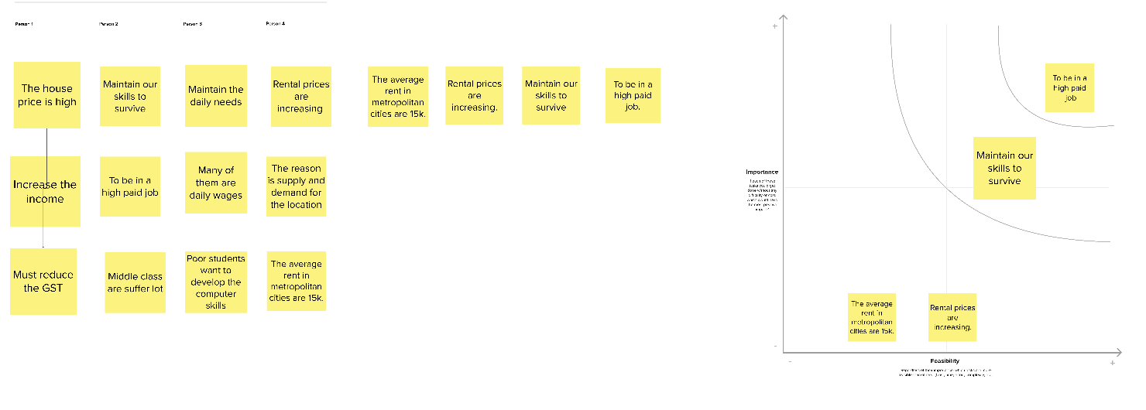

**DISCUSSION**

Creating a brainstorm map for unlocking insights into the analysing housing prices in metropolitan cities using Tableau involves identifying key data sources, visualization techniques, and analysis goals.

**3.STATISTICAL ANALAYSIS**

**Fig 3: Data source connection**

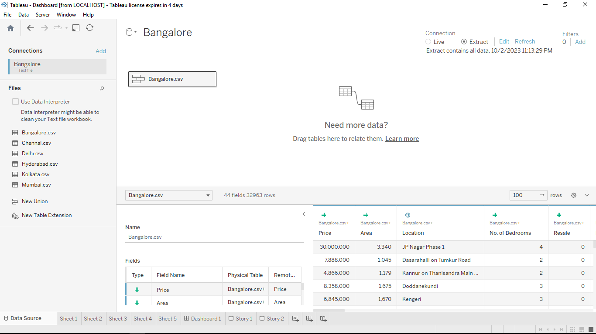

**Discussion**

It can help you to find information about the specific data of the six major metropolitan cities in India.

**Fig 4: Vastu complaints based on locations**

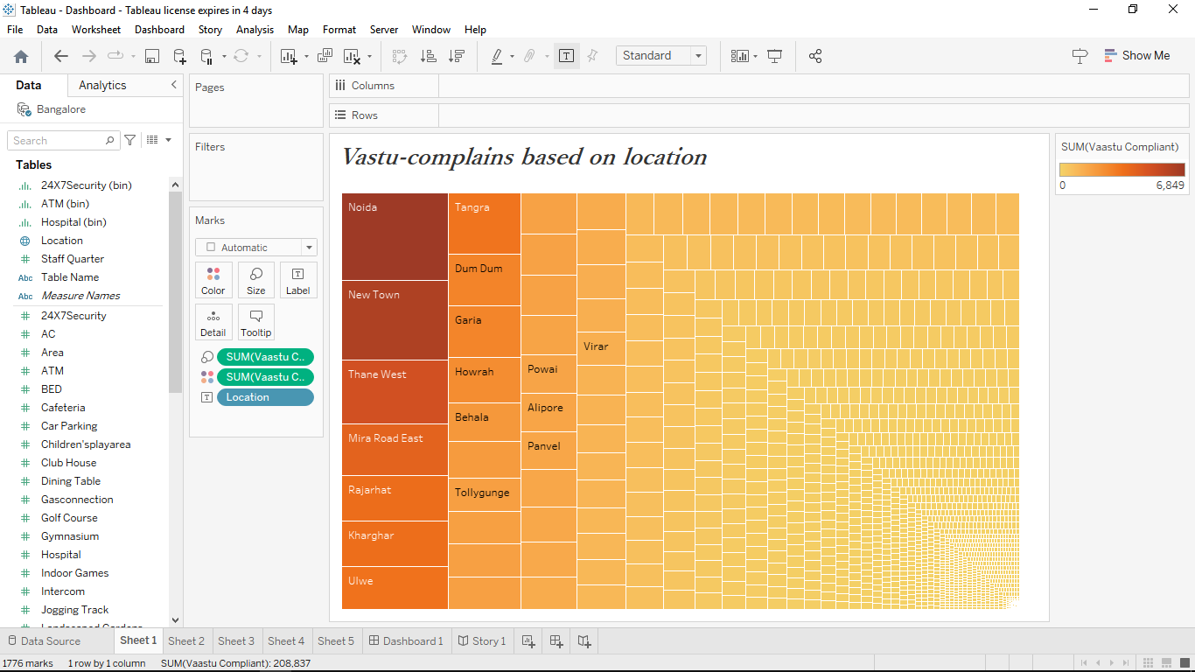

**Discussion**

It can help you find information about the vastu locations complaints for the housing data.

**Fig 5: Latitude and Longtitude based on location**

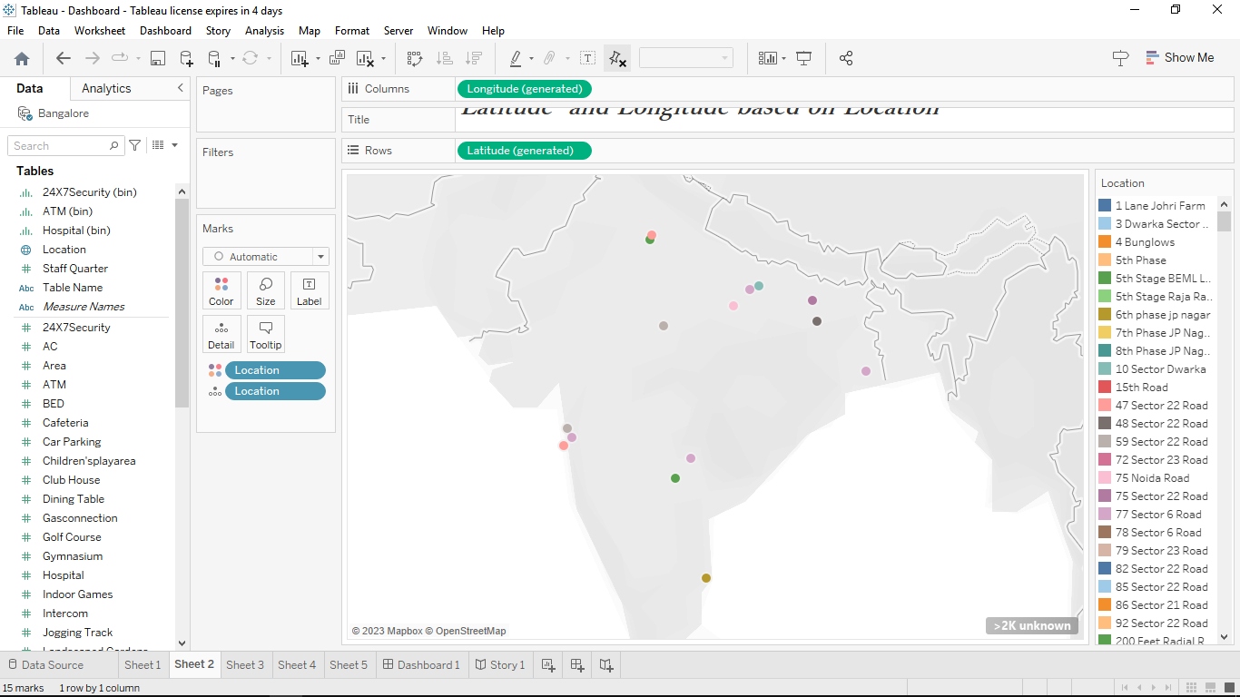

**Discussion**

Latitude and longtitude based on locations in India Map. It involves the location based on latitude and longtitude in Indian Map.

**Fig 6:Dining table and its prices**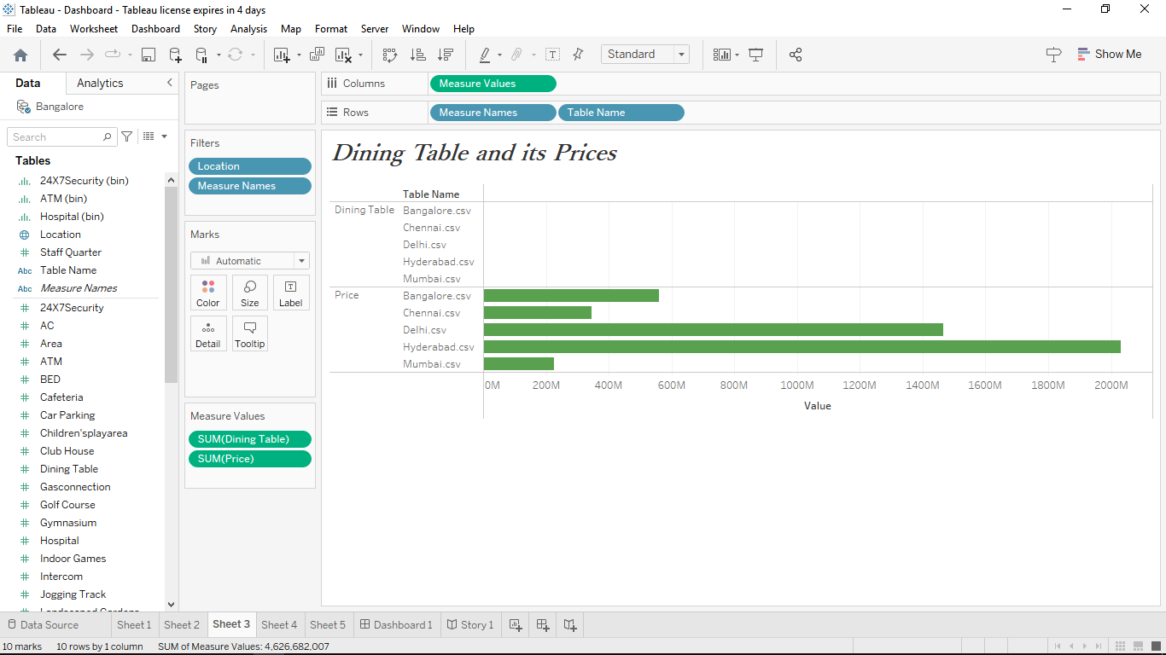

**Discussion**

Dining table and its prices increasing based on the metropolitan cities. It It involves dining table ,prices and its values in the metropolian cities.

**Fig 7: Car Parking in Hospitals**

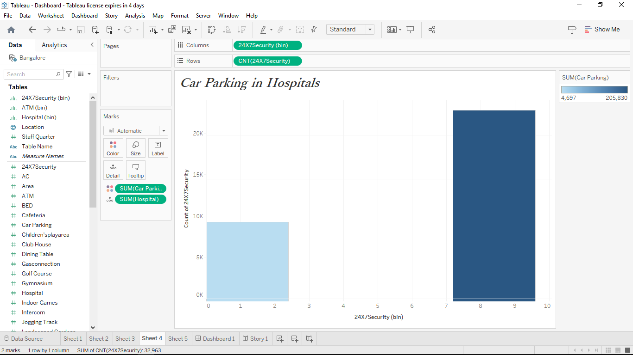

**Discussion**

Car parking in hospitals based on the metropolitan cities. It consists of count of 24*7 security and the hospital facility.

**Fig 8 : Staff quarters in Hospitals**

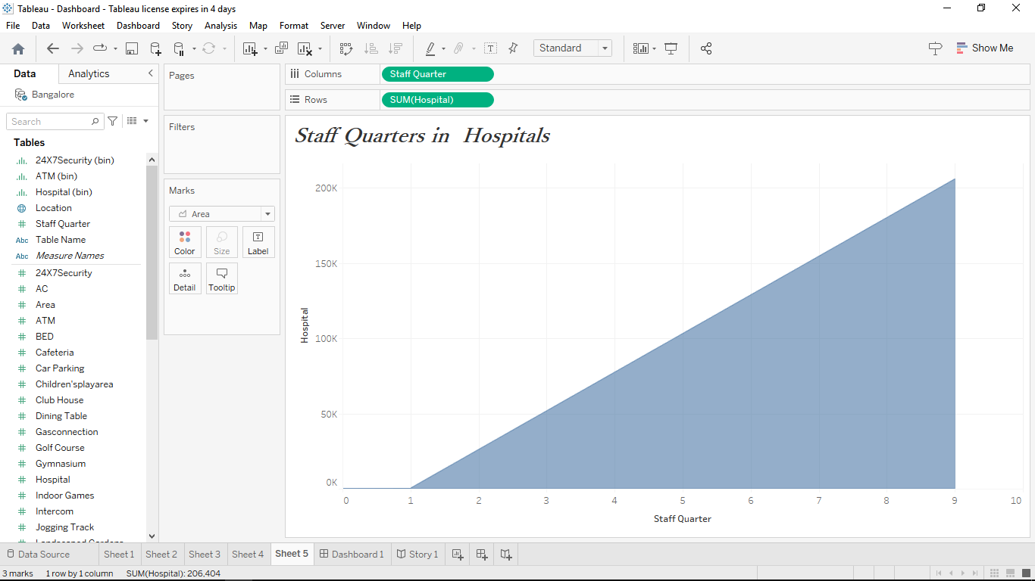

**Discussion**

Staff Quarters in hospital based on metropolitan cities. It involves the staffquarters in the hospital based on the staff and their sum of hospitals.

**Fig 9 : Dashboard**

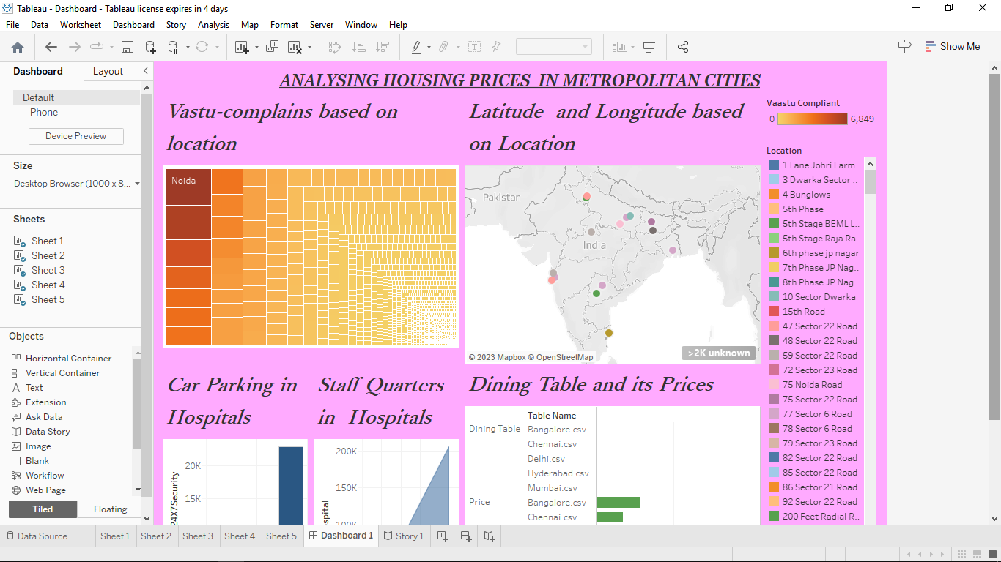

**Dashboard Discussion:**

* Data Collection: Gather data on property listings, including details like location, size, amenities, and prices. Online real estate websites, government records, or APIs can be sources.
* Data Cleaning: Clean the data by handling missing values, outliers, and inconsistencies.
* Exploratory Data Analysis (EDA): Visualize and summarize the data to identify trends, patterns, and correlations. EDA helps you understand the distribution of prices, factors affecting prices, and geographical trends.

**4. SUMMARY & CONCLUSION**

Analysing housing prices in metropolitan cities involves examining the factors affecting property values in densely populated areas. Key elements include economic conditions, market trends, government policies, and urban development. This analysis serves various purposes, such as guiding real estate investment, informing homebuyers, and aiding urban planning. However, it comes with challenges, including data complexity, volatility, and ethical concerns.

Analysing housing prices in metropolitan cities is an indispensable practice with wide-reaching implications. It empowers stakeholders to make informed decisions, whether they are homebuyers seeking affordability, investors eyeing opportunities, or policymakers aiming for balanced urban development. Despite its complexities and challenges, this analysis plays a crucial role in shaping the dynamics of housing markets and the urban landscape as a whole. It's a vital tool for addressing housing affordability, social equity, and sustainable urban development in an increasingly urbanized world.

**5. FUTURE SCOPE**

The future scope of analysing housing prices in metropolitan cities is expected to evolve in several ways:

1. Advanced Data Analytics: with the advent of big data and AI technologies, housing price analysis will become more data-driven and sophisticated. Machine learning models can provide more accurate predictions and insights into market trends.

2. Geospatial Analysis: Geographic information systems (GIS) and geospatial data will play a larger role in housing price analysis, allowing for precise location-based insights and visualizations.

3. Environmental Considerations: Future analyses will likely incorporate environmental factors, such as climate change risks and sustainability, to assess the long-term viability of housing markets.